**Softwares** **that will be required to run the project**

* + **Visual Studio Code**
  + **Anaconda**
  + **Tensorflow**
  + **OpenCV**
  + **NumPy**
  + **Matplotlib**
  + **Keras**

**Steps to run project application**

# Visual Studio Code

## **Install Visual Studio Code**

**To start, download and install** [**Visual Studio Code**](https://code.visualstudio.com/download)**.** When installing Visual Studio Code (VSC), **Keep all the default settings.**

Once VSC is installed, open VSC and **install** the **Python extension and** the **Pylance extension** (if they’re not already installed).

# **Anaconda**

### **Download and install Anaconda:**

Head over to [anaconda.com](https://www.anaconda.com/distribution/#windows) and install the latest version of Anaconda. Make sure to download the “Python 3.7 Version” for the appropriate architecture.

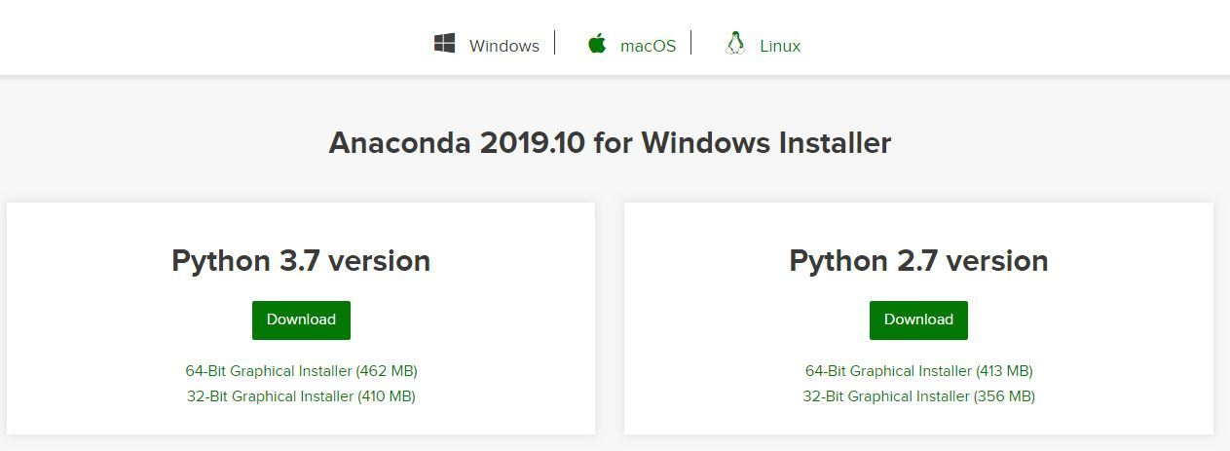

Begin with the installation process:

* Getting Started:  
  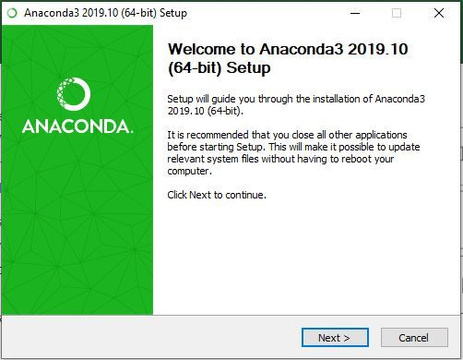
* Getting through the Licence Agreement:  
  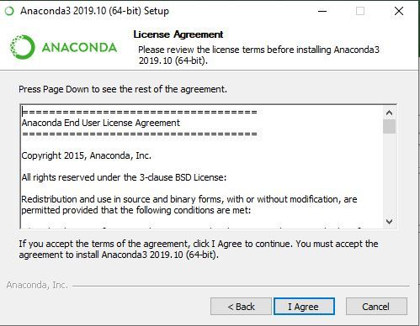
* Select Installation Type: Select Just Me if we want the software to be used by a single User  
  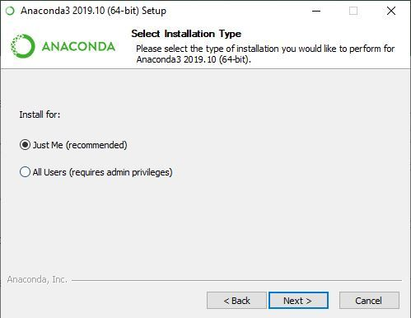
* Choose Installation Location:  
  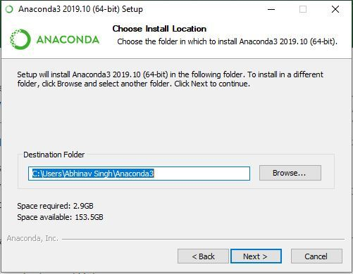
* Advanced Installation Option:  
  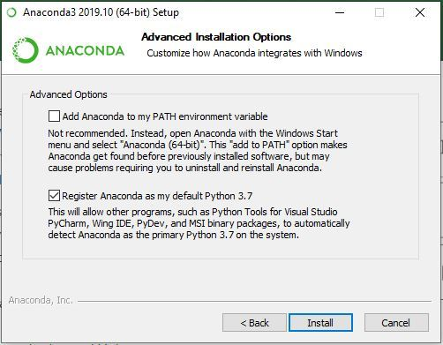
* Getting through the Installation Process:  
  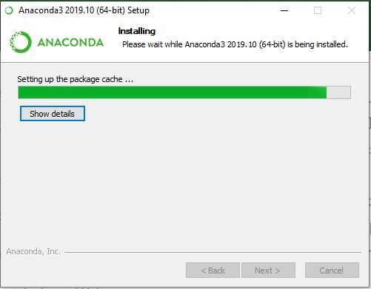
* Recommendation to Install Pycharm:  
  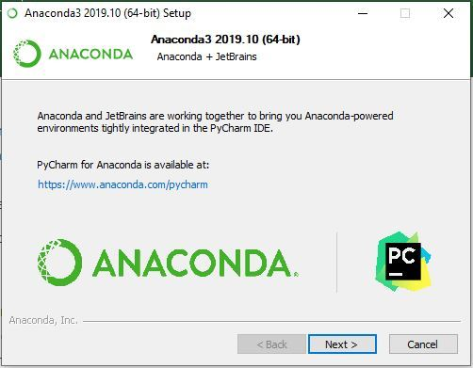
* Finishing up the Installation:  
  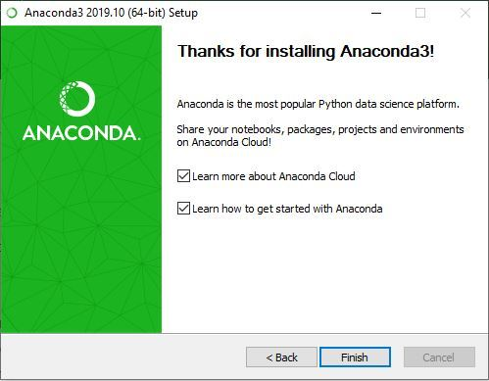

### Working with Anaconda:

Once the installation process is done, Anaconda can be used to perform multiple operations. To begin using Anaconda, search for Anaconda Navigator from the Start Menu in Windows

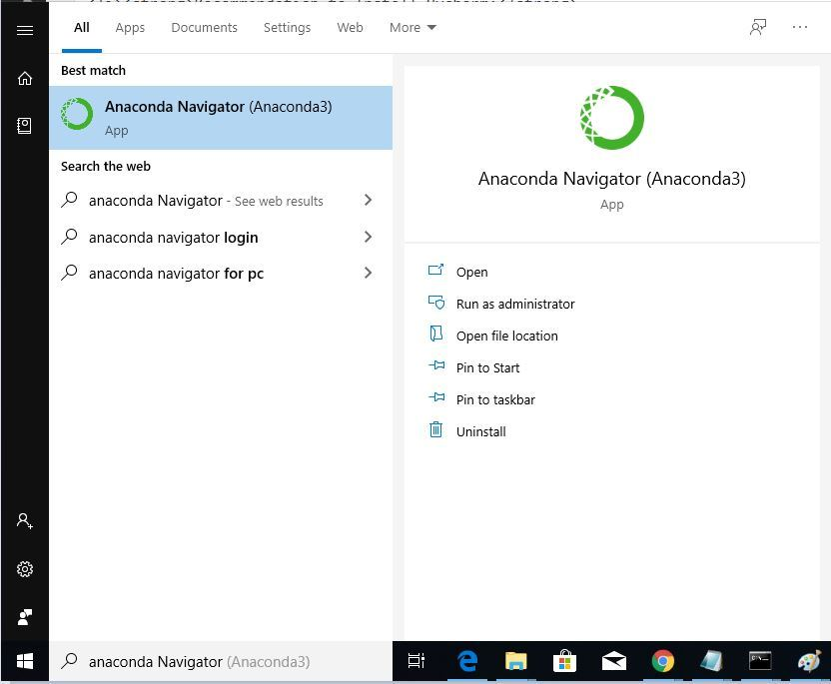

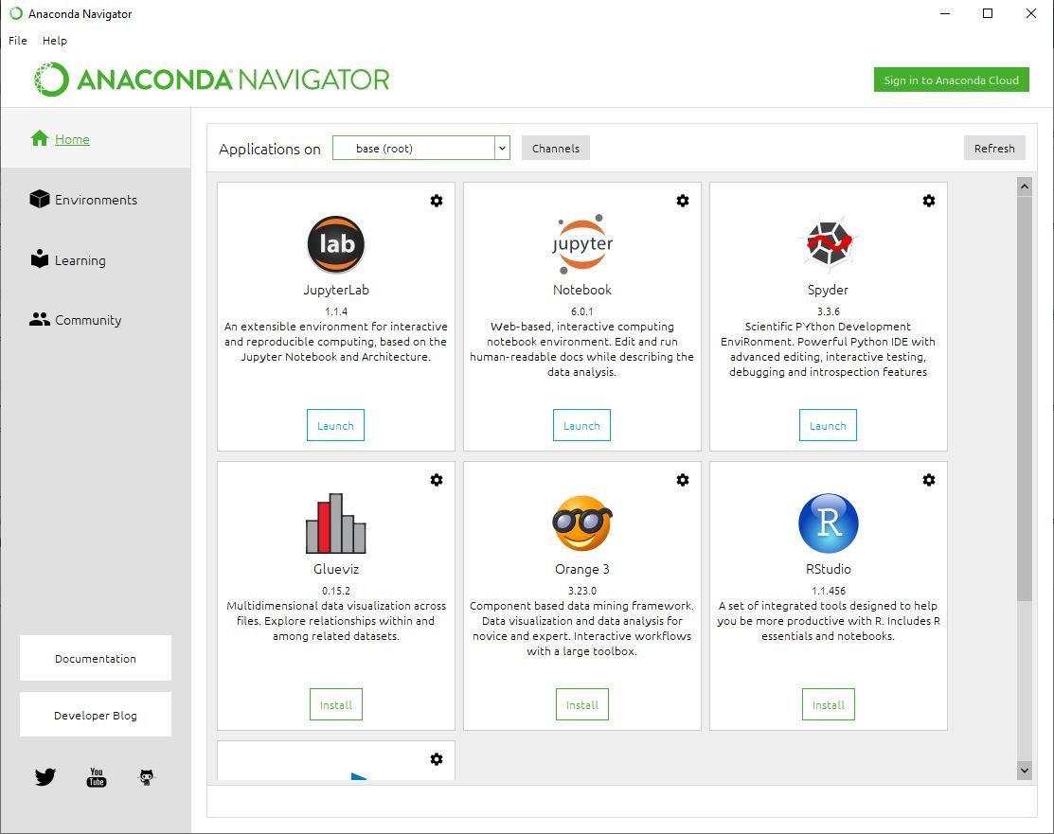

# **TensorFlow**

# **TensorFlow is a free and open-source software library for machine learning and artificial intelligence. It can be used across a range of tasks but has a particular focus on training and inference of deep neural networks**

**TensorFlow with conda is supported on 64-bit Windows 7 or later, 64-bit Ubuntu Linux 14.04 or later, 64-bit CentOS Linux 6 or later, and macOS 10.10 or later.**

**The instructions are the same for all operating systems. No apt install or yum install commands are required.**

## **Install TensorFlow**

1. **Download and install** [**Anaconda**](https://www.anaconda.com/download/) **or the smaller** [**Miniconda**](https://conda.io/miniconda.html)**.**
2. **On Windows open the Start menu and open an Anaconda Command Prompt. On macOS or Linux open a terminal window. Use the default bash shell on macOS or Linux.**
3. **Choosing a name for our TensorFlow environment, such as “tf”.**
4. **To install the current release of CPU-only TensorFlow, recommended for beginners:**

**conda create -n tf tensorflow**

**conda activate tf**

**Or, to install the current release of GPU TensorFlow on Linux or Windows**

**conda create -n tf-gpu tensorflow-gpu**

**conda activate tf-gpu**

**TensorFlow is now installed and ready to use.**

# OPENCV

**OpenCV (Open Source Computer Vision) is a computer vision library that contains various functions to perform operations on pictures or videos. It was originally developed by Intel but was later maintained by Willow Garage and is now maintained by Itseez. This library is cross-platform, that is it is available in multiple programming languages such as Python, C++ etc.**



**Steps to import OpenCV on anaconda in windows**

**Install OpenCV**

**Step 1:-** After installing the anaconda open the Anaconda Prompt.

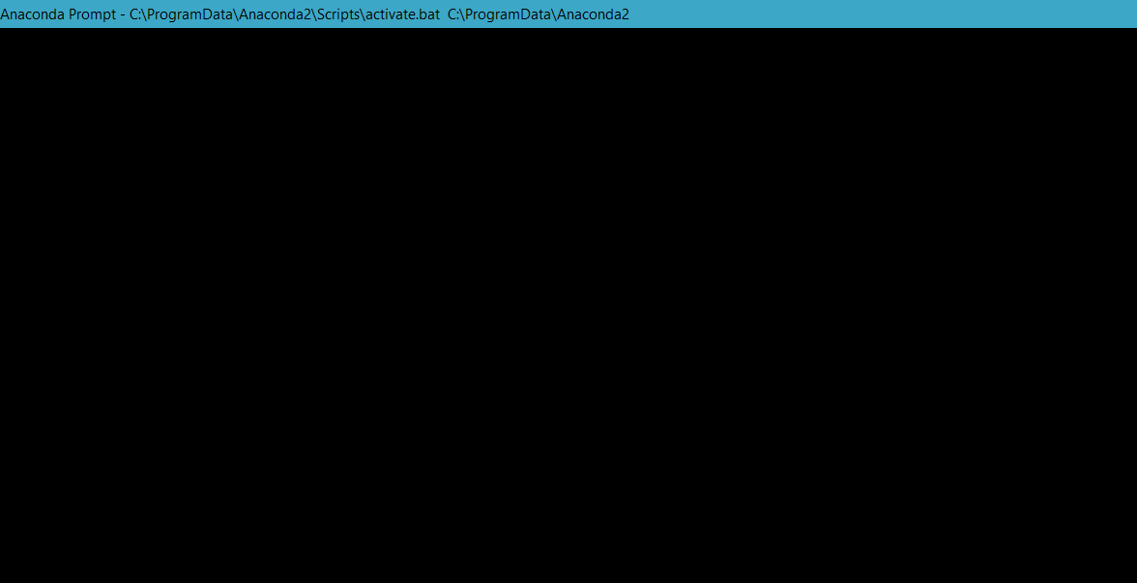

**Step 2:-** Type the given command, press enter, and let it download the whole package.

**Command**

**conda install -c menpo opencv**

**Step 3:-** Now simply import OpenCV in the python program in which we want to use image processing functions.

**Examples:** Some basic functions of the OpenCV library (These functions are performed on Windows flavour of Anaconda but it will work on linux flavour too)

### **Reading an image**

**img = cv2.imread('LOCATION OF THE IMAGE')**

The above function imread stores the image at the given location to the variable img.

Converting an image to grayscale

**img = cv2.imread('watch.jpg',cv2.IMREAD_GRAYSCALE)**

The above function converts the image to grayscale and then stores it in the variable img.

Showing the stored image

**cv2.imshow('image',img)**

The above function shows the image stored in img variable.

Save an image to a file

**cv2.imwrite(filename, img)**

The above function stores the image in the file. The image is stored in the variable of type Mat that is in the form of a matrix.

Reading video directly from the webcam

**cap = cv2.VideoCapture(0)**

Stores live video from our webcam in the variable cap.

Reading a video from local storage

**cap = cv2.VideoCapture('LOCATION OF THE VIDEO')**

Stores the video located in the given location to the variable.

To check if the video is successfully stored in the variable

**cap.isOpened()**

**the cap is the variable that contains the video. The above function returns true if the video is successfully opened, else returns false.**

**Release the stored video after processing is done**

**cap.release()**

The above function **releases the video stored in the cap.**

# NumPy

After installing the **Anaconda** distribution of Python, **NumPy comes pre-installed** and **no further installation steps are necessary**.

# Matplotlib

The **Anaconda** distribution of Python **comes with Matplotlib pre-installed** and **no further installation steps are necessary**.

# Keras

## Installing the Keras

**Operating System** Windows

**Packager** conda

Install conda using the [Anaconda or miniconda](https://docs.conda.io/projects/conda/en/latest/user-guide/install/) installers or the [miniforge](https://https//github.com/conda-forge/miniforge#miniforge) installers (no administrator permission required for any of those).

Then run:

**conda create -n sklearn-env -c conda-forge scikit-learn**

**conda activate sklearn-env**

To check our installation we can use

**conda list scikit-learn** # to see which scikit-learn version is installed

**conda list**  # to see all packages installed in the active conda environment

**python -c "import sklearn; sklearn.show_versions()"**

# Steps to Run Project Application

**Step 1:** After installing necessary dependencies, open the project folder in vs code either by drag and drop or giving the path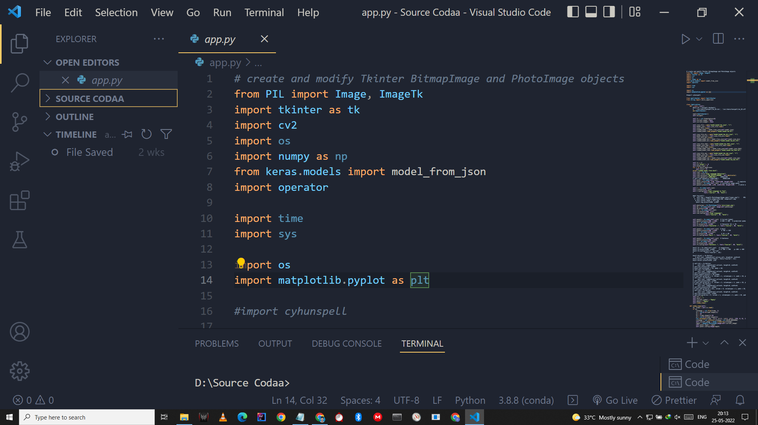

**Step 2:** Click Python: Select Interpreter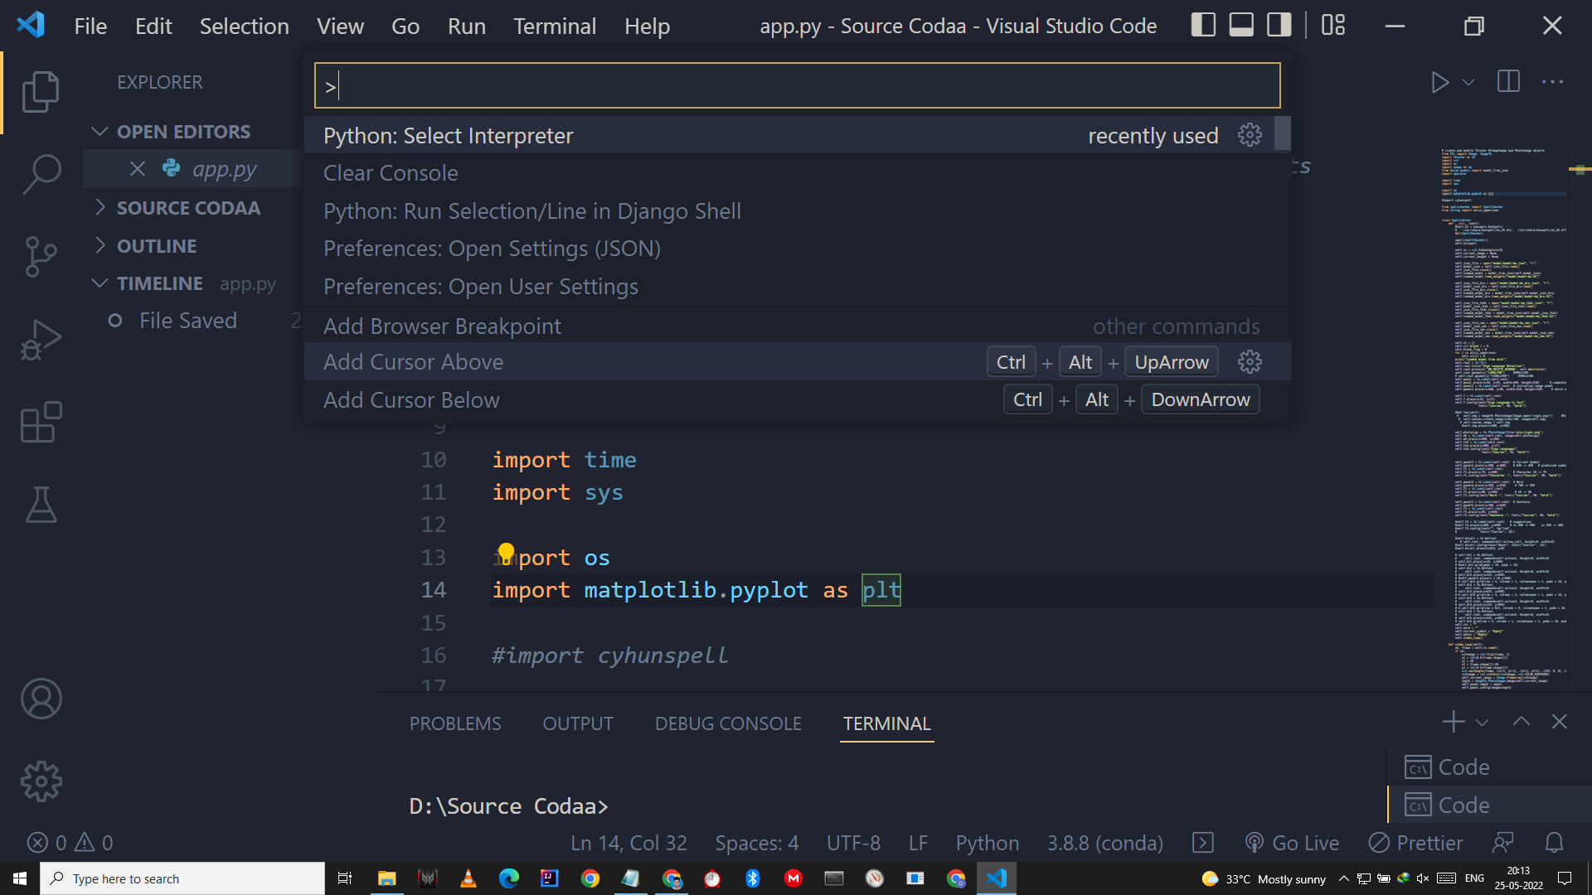

**Step 3:** Then Select the interpreter shown in the below image

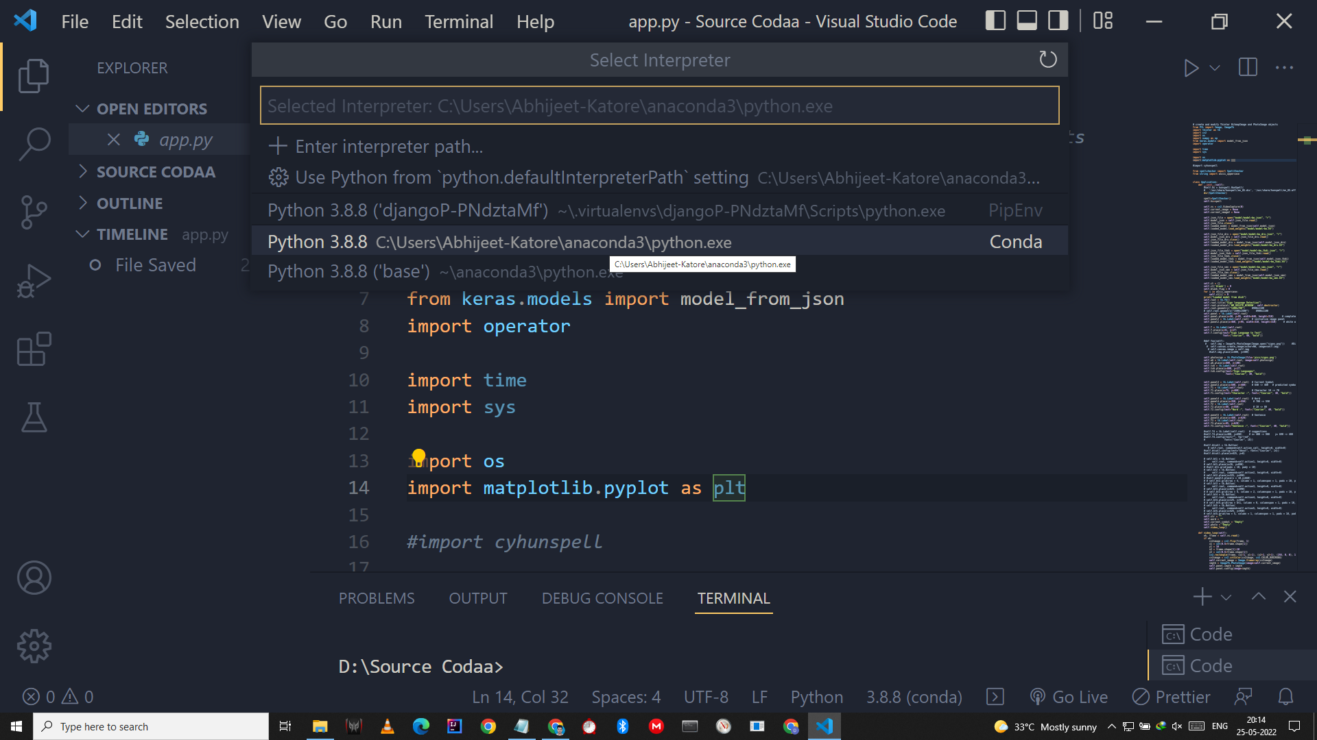

**Step 4:** On the Navigation Pane select the app.py and click on the run button on the top right

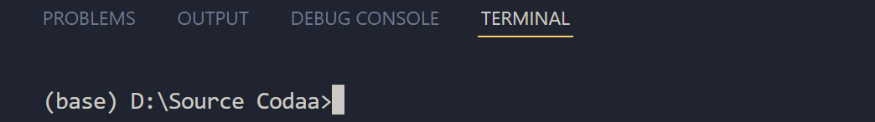

We can see that an Anaconda environment is established

Now again Click the same run button to run the project

